Event Action Code Practice
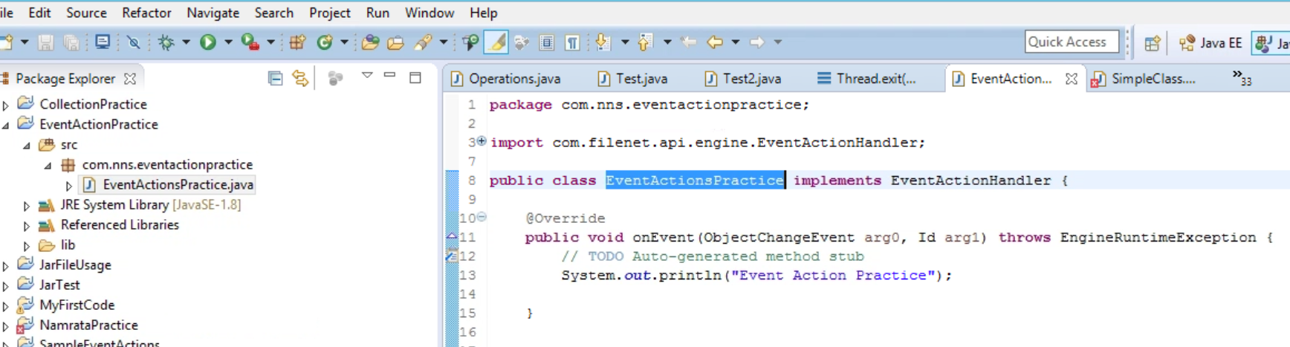
1. Create a project, package, class
2. Add all the necessary jar and add to build path.
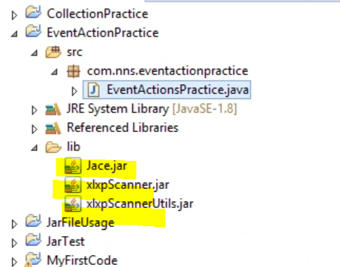
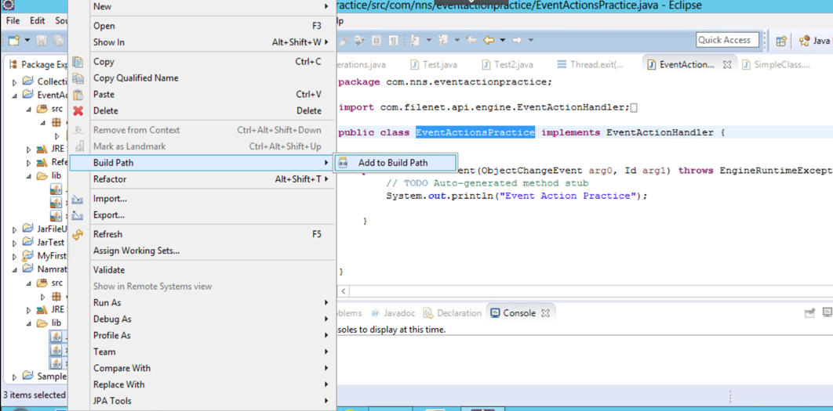
3. After creating a class, implements Interface EventActionHandler.
Let suppose you are giving simple println statement
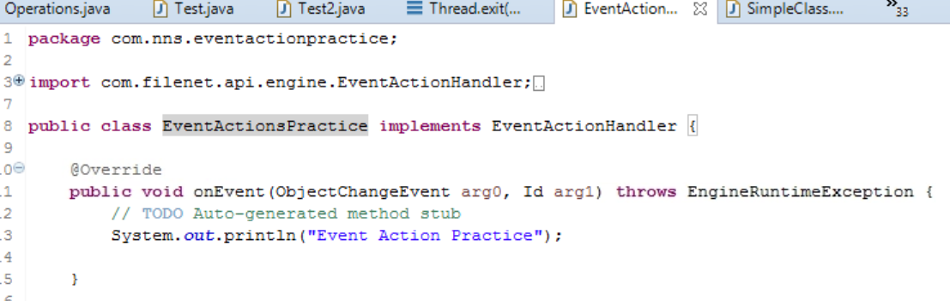
Once you can execute and make a jar file.
4. Login ACCE and go to event action
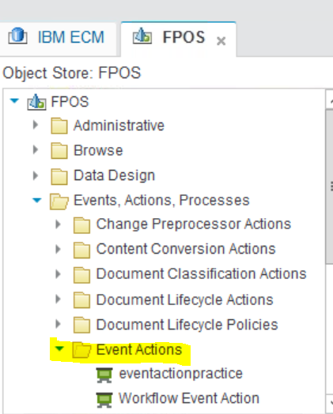
5. Right click and create new.
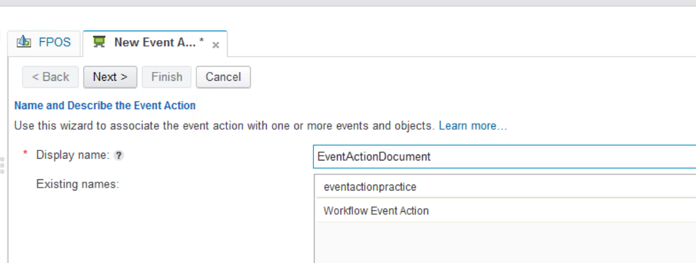

6. Click next,, give the package name first . Class name and tick the code module.
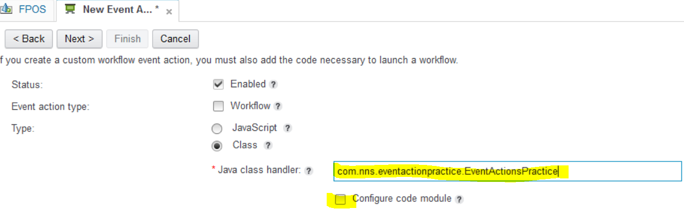

7. Now Browse and give the name , select that module and move to next.
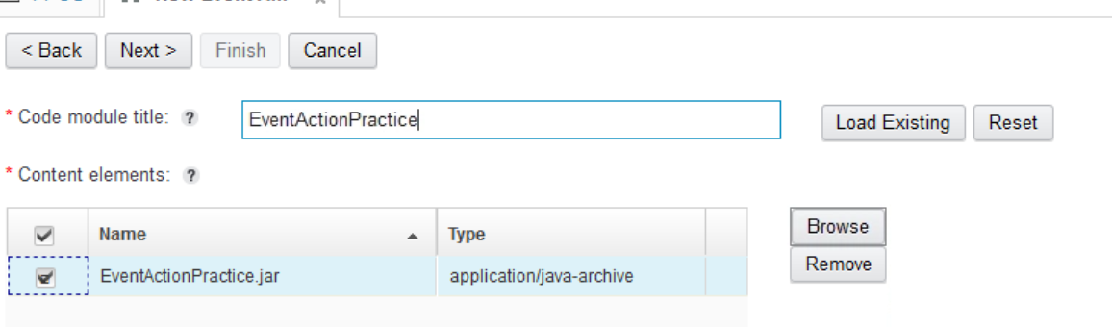
8. Now press Finish
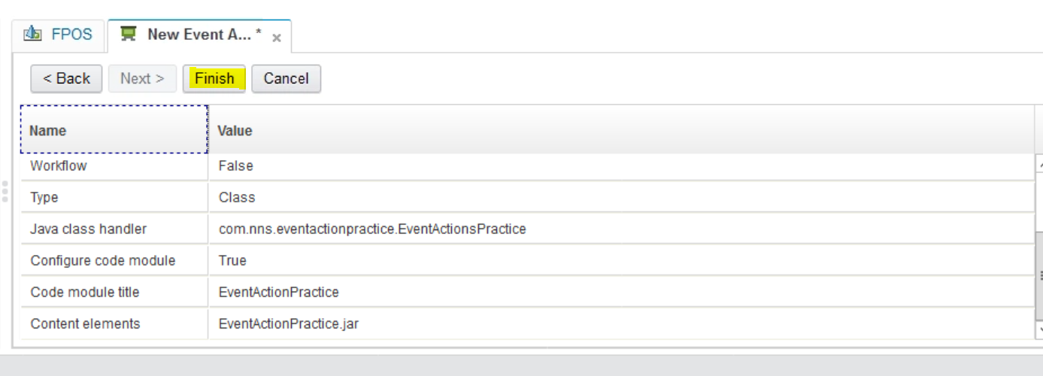
9. Close.
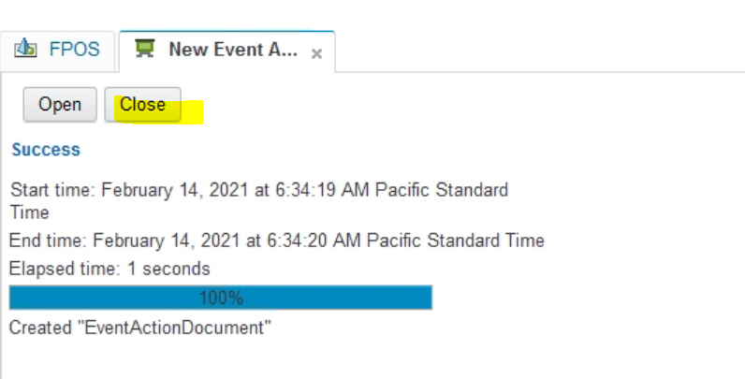
10. Go to the subscription and create new.
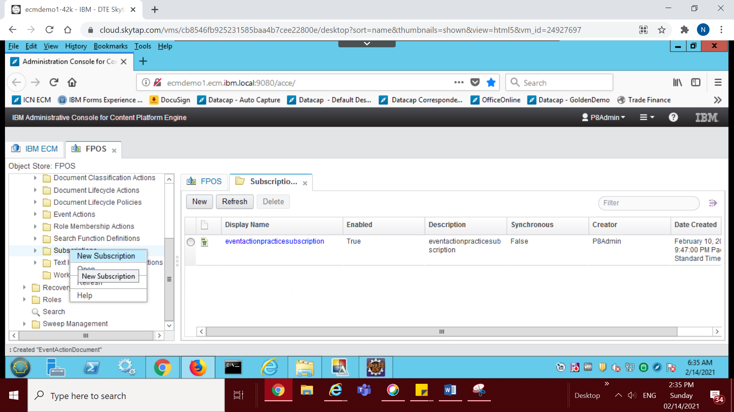

11. Give the name of the event.
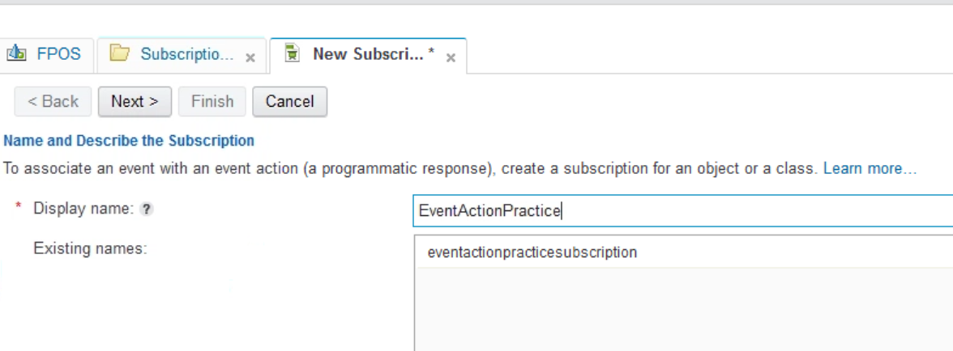
12. Select the Doc Class and what is the type of that class.
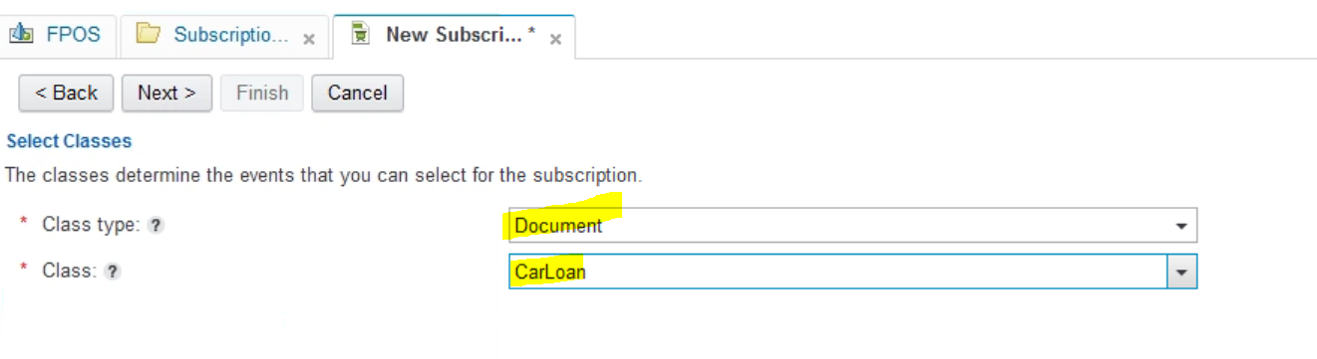
13. Just do Next.
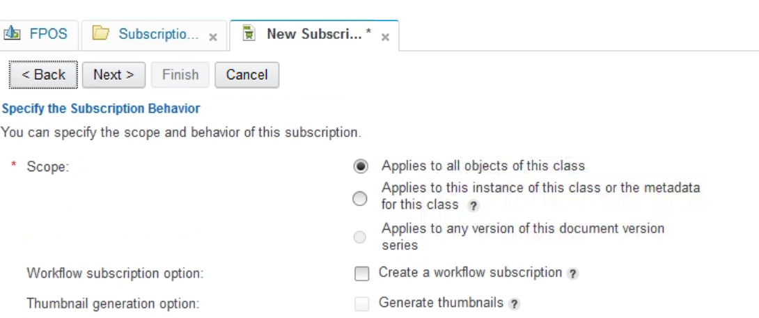

14. Now select for which event you want to create subscription.
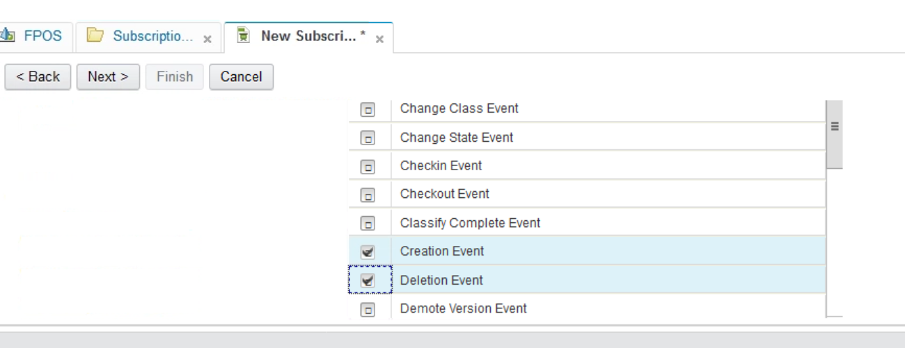
15. Select Event Action. For this we created high lighted one.
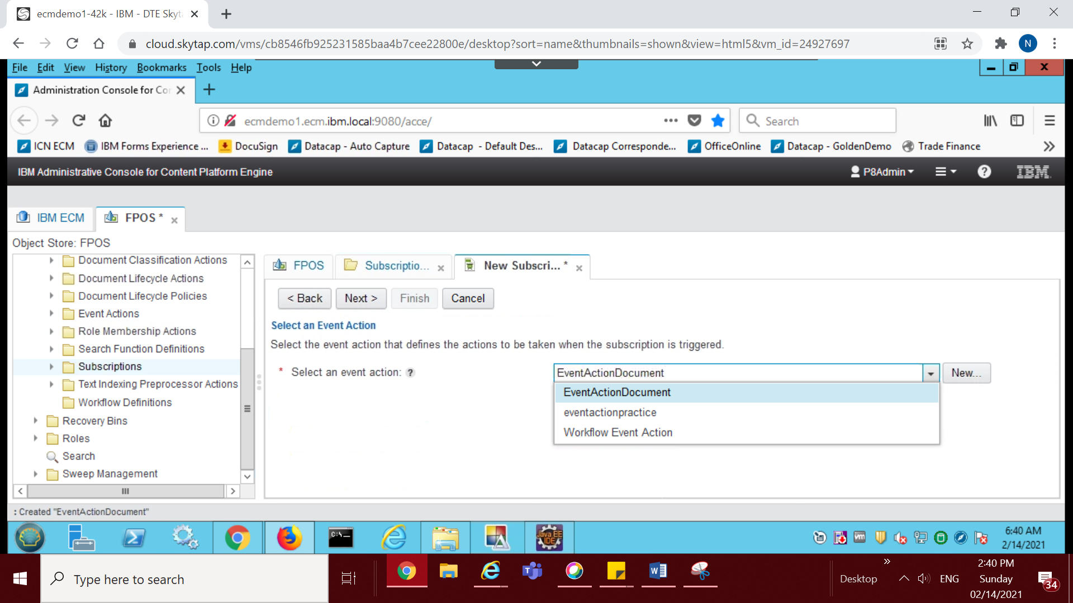
16. Do next , next and Finish.
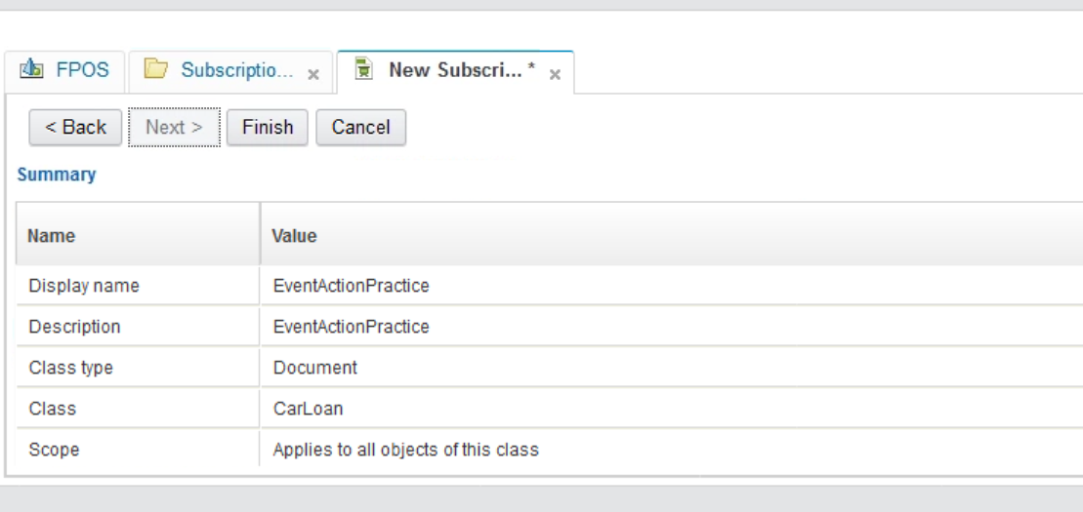
17. Create a document for CarLoan
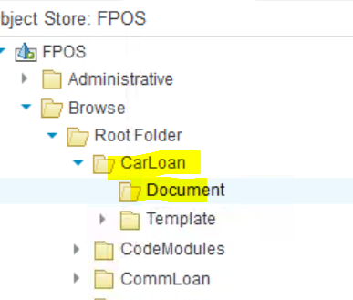
18. Now check the systemout log.
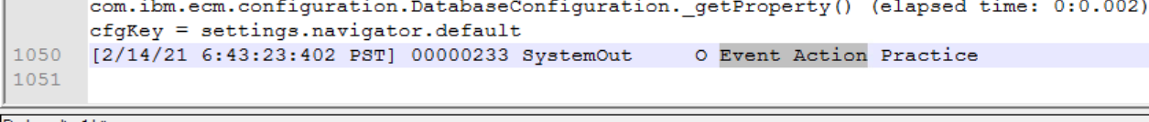

19. It hits, means whenever you are creating an document, it will hit because you select creation action.

